**`**

**MATHEMATICS METHODS UNIT 1 TEST 3**

**CALCULATOR FREE NAME: __________________________**

**TIME ALLOWED: 20 MIN**

***Show all your working clearly.*** *Your working should be in sufficient detail to allow your answers to be checked readily and for marks to be awarded for reasoning. Incorrect answers given without supporting reasoning cannot be allocated any marks. For any question or part question worth more than two marks, valid working or justification is required to receive full marks. If you repeat any question, ensure that you cancel the answer you do not wish to have marked.*

**QUESTION 1 [6 MARKS: 2, 1, 1, 1, 1]**

The spinners A and B are divided into 4 and 5 equal sectors respectively. They are spun at the same time and the numbers to which the arrows point are added.

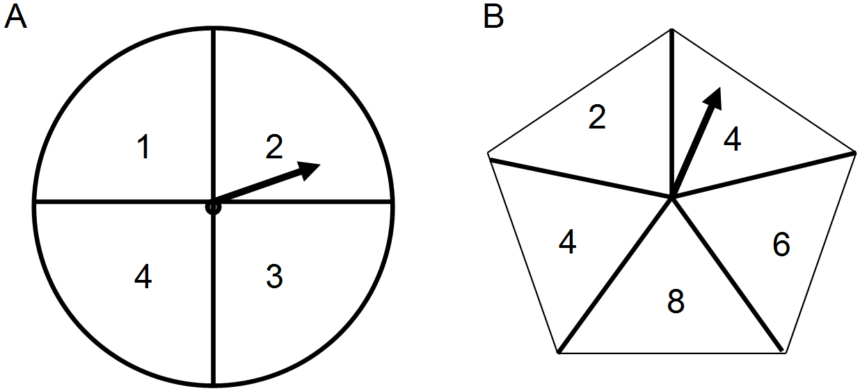

(a) Use a suitable sample space to show all possible outcomes.

(b) What is the probability that the total is even?

(c) What is the probability that the total is 12?

(d) What is the probability that the total is even when the result on spinner A is an even number?

(e) What is the probability that the total is at least 10 when it is known that the total is greater than or equal to 7?

**QUESTION 2 [8 MARKS: 3, 5]**

Solve for  within the given domain:

1. cos+sin=0 0

1. 2sin 0

**QUESTION 3 [3 marks: 1, 1, 1]**

Students in Year 11 were surveyed to determine the number who had played competition sport and undertaken paid work the previous weekend. The results are provided in the table.

|  |  |  |  |  |
| --- | --- | --- | --- | --- |
|  | | Played competition sport | | |
| Yes | No | Total |
| Undertaken paid work | Yes | 54 | 11 | 65 |
| No | 50 | 25 |  |
| Total | 104 |  | 140 |

If a student is selected at random from this Year 11 group, what is the probability that:

(a) they played competition sport and undertook paid work?

(b) they either played competition sport or undertook paid work?

(c) they did not play competitive sport, given that they had undertaken paid work?

**QUESTION 4 [5 marks: 1, 1, 1, 1, 1]**

The universal set is the set of integers from 1 to 20,  is the set of numbers divisible by 3,  is the set of square numbers and  is the set of prime numbers.

(a) List the elements of each set:

(b) Describe the set **

(c) Determine **

(d) Determine **

(e) A number is selected at random from the universal set,determine **

**TOTAL MARKS: 22**

<http://wace1516.scsa.wa.edu.au/mathematics/> (accessed 1st May 2015)

O T Lee.,2014. WACE Revision Series, Mathematics Methods, ATAR Course, Year 11 Units 1 and 2, Singapore, Academic Task Force